ACCEPTED FOR PUBLICATION IN AMERICAN EDUCATIONAL RESEARCH JOURNAL
A Multination Study of Socioeconomic Inequality in Expectations for Progression to Higher Education: The Role of Between School Tracking and Ability Stratification

Philip D. Parker^{*1}, John Jerrim², Ingrid Schoon², Herbert W. Marsh¹
¹Institute of Positive Psychology and Education, Australian Catholic University.
²Institute of Education, University College London

Acknowledgements. This research was partially funded by the Australian Research Council (DE140100080), the Economic and Social Research Council, and the Jacobs Foundation.
*Corresponding Author: Dr. Philip D Parker
Institute for Positive Psychology and Education
Faculty of Health Sciences Australian Catholic University
25a Barker Road, Strathfield NSW 2135 E: philip.parker@acu.edu.au.

Philip D. Parker is an Australian Research Council funded researcher at the Institute for Positive Psychology and Education at the Australian Catholic University. He received his doctorate in Educational Psychology from the University of Sydney. His major research interest includes educational inequality, developmental transitions, and educational attainment.
John Jerrim is a Reader in Educational and Social Statistics at the UCL Institute of Education, UK. He received his doctorate in Social Statistics from the University of Southampton. His research focuses on international comparisons of educational attainment, and the evaluation of educational programs and policies.
Ingrid Schoon is Professor of Human Development and Social Policy at the Institute of Education, University College London. She is Research Director of the Centre for Youth Transitions (CAYT), coordinator of the international post-doctoral Jacobs Foundation Fellowship ‘PATHWAYS to Adulthood’, and is Principal Co-Investigator for the ESRC funded Centre for Learning and Life Chances in Knowledge Economies and Societies (LLakes). Her research interests are focused on issues of human development across the life course, in particular the transition from dependent childhood to independent adulthood, the study of risk and resilience, the realization of individual potential in a changing socio-historical context, and the intergenerational transmission of (dis)advantage.
Herbert W. Marsh is a world-leading researcher in educational psychology at the Institute for Positive Psychology and Education and Australian Catholic University. He is the author of internationally recognized psychological tests that measure self-concept, motivation and university students’ evaluations of teaching effectiveness. He is a widely published world expert in his field and co-edits the International Advances in Self Research monograph series. In addition to his methodological focus on structural equation models, factor analysis, and multilevel modelling, his major substantive interests include self-concept and motivational constructs; evaluations of teaching/educational effectiveness; developmental psychology; sports psychology; the peer review process; gender differences; peer support and anti-bullying interventions.
Abstract
Persistent inequalities in educational expectations across societies are a growing concern. Recent research has explored the extent to which inequalities in education are due to primary effects (i.e. achievement differentials) versus secondary effects (i.e. choice behaviors net of achievement). We explore educational expectations in order to consider whether variations in primary and secondary effects are associated with country variation in curricular and ability stratification. We use evidence from the PISA 2003 database to test the hypothesis that a) greater between-school academic stratification would be associated with stronger relationships between socioeconomic status and educational expectations; and b) when this effect is decomposed, achievement differentials would explain a greater proportion of this relationship in countries with greater stratification. Results supported these hypotheses.
Key Words: educational expectations; educational inequality; primary and secondary effects; curricular tracking; ability stratification.
Supplementary material: https://pdparker.github.io/EducationalExpectations/

Introduction
In the last 50 years, research has found significant declines in gender inequality in expectations and attainment for tertiary education (Goldin, Katz, & Kuziemko, 2006; McDaniel, 2010; Organisation for Economic Co-operation and Development [OECD], 2010; Sikora & Saha, 2009). Similarly, declines in expectations and achievement gaps by ethnicity have also been observed (Lareau, 2003; Nisbett, 2005; Reardon, 2011). In contrast, large differences in educational expectations and attainment by socioeconomic status have remained in much of the OECD (Breen, Luijkx, Müller, & Pollak, 2009; Jerrim, Chmielewski, & Parker, in press; Nash, 2003; OECD, 2011; Reardon, 2011; Van de Werfhorst & Hofstede, 2007). While there is a long history of research on educational expectations based on single country analyses, the research on how the effect of socioeconomic status varies across countries is relatively limited (though see Buchmann & Park, 2009; McDaniel, 2010). The research that has been done has typically categorized countries as having either comprehensive or curricular tracking schooling systems; with findings indicating that tracking is associated with poorer outcomes for disadvantaged youth (e.g., Buchmann & Park, 2009). However, there is considerable variance in the way school systems are organized within these categories. This includes variation in both the extent of curricular tracking (see Bol, Witschge, Van De Werfhorst, & Dronkers, 2013) and ability stratification (see Dupriez, Dumay, & Vause, 2008). We explore the influence of both in the current research.
Educational expectations are an important area to address as they have critical implications for students’ subsequent development. Theories of reasoned action and planned behavior suggest that expectations are the single most important predictor of the choices that people will make when given the opportunity (Madden, Ellen, & Ajzen, 1992; Montaño & Kasprzyk, 2008). In addition, expectations are also important outcomes in their own right, with links to wellbeing and identity (see Dietrich, Parker, & Salmela-Aro, 2012). Expectations also differ by social background, even after controlling for academic ability. They thus provide critical insights into the processes by which differentiation in educational outcomes occur (Van de Werfhorst & Hofstede, 2007).
The aim of this study was to examine the association between country differences in ability and curricular stratification, and children’s expectations of obtaining a bachelor’s degree. In addition, the study also assesses the extent to which stratification is associated with primary (ability) versus secondary (non-achievement choice process differentials) effects in the transmission of educational inequality. In this research we focus on expectations of a university level of education for several reasons. First, it is consistent with previous research in this area (Buchmann & Park, 2009; McDaniel, 2010). Second, in most Western countries there is an increasing requirement to have a tertiary level of education in order to protect oneself from economic hardship and to succeed in the labor market (OECD, 2010, 2011). This is important given that recent increases in the employability of college graduates has largely come at the cost of those who do not go to university (Checchi, 2006; Côté, 2006). Indeed, social status positions that may have previously required a high-school level of education now require at least a university degree (Piketty, 2014). Finally, although educational expectations do not perfectly predict later educational and occupational attainment, they are nevertheless very strongly associated with such later lifetime outcomes (McDaniel, 2010). This is important as studies of expectations acknowledge that inequalities do not just emerge at the transition point, but have their origins much earlier in young people’s educational careers (Grodsky & Riegle-Crumb, 2010).

Literature Review and Theory
Socioeconomic Status and Primary and Secondary Effects
Research suggests that inequalities in educational expectations by socioeconomic status are partly driven by differences in academic achievement (Sikora & Saha, 2009). However, theories dating back to the 1960s indicate that factors independent of achievement are also likely to be important. This is likely to include the influence of significant others, perceptions of the subjective costs and benefits of continuing education, and school contextual effects, amongst others (Buchmann & Park, 2009; Sewell, Haller, & Portes, 1969; see also Morgan 1998; Morgan 2005; Parker, Marsh, Ciarrochi, Marshall, Abduljabbar, 2014). In this way, research on educational expectations have notable similarities with the status literature, in that they are determined by both primary effects (achievement differentials) and secondary effects (non-achievement choice process differentials; Boudon, 1974).
Primary effects refer to socioeconomic differences in educational transitions that are attributable to differences in achievement. That is, students from lower socioeconomic backgrounds have lower levels of educational achievement (on average) than their higher socioeconomic status peers (Goldthorpe, 2007; Hauser, 2010). These differences may come from a number of sources including social context, maturation practices, and resource availability (Cunha, Heckman, Lochner, & Masterov, 2006; Heckman, 2006; Lareau, 2003; Reardon, 2011)². Secondary effects, on the other hand, refer to socioeconomic differences in choice behaviors at and leading up to educational transitions, which influence young people’s destinations net of that which can be explained by academic achievement. In other words, young people from less privileged backgrounds tend to choose less ambitious educational pathways than their more advantaged peers, even when they were equally able (Jackson, Erikson, Goldthorpe, & Yaish, 2007; Kerckhoff, 1993, 2001; Parker, Bodkin-Andrews, Marsh, Jerrim, & Schoon, 2013; Vondracek, Lerner, & Schulenberg, 1986).
Primary and Secondary Effects in Educational Expectations
Similar thinking relating to primary and secondary effects implicitly underlies much research and theory on educational expectations. It is now well established that socioeconomic status is a crucial predictor of such expectations (McDaniel, 2010). Likewise, the Wisconsin model (see Sewell et al., 1969; see also Dietrich et al., 2012; Bozick, Alexander, Entwisle, Dauber, & Kerr, 2010) suggests that socioeconomic status has an effect on both occupational and educational expectations via academic performance (primary effects in the work of Boudon, 1974) and non-achievement related factors such as the influence of significant others (secondary effects). Put simply, young people from lower socioeconomic backgrounds have less ambitious expectations than their more advantaged peers, even when they have similar levels of achievement.
Relatively little empirical work, however, has framed research on expectations explicitly through the lens of primary and secondary effects. Van de Werfhorst and Hofstede (2007) represent one of the few exceptions, which has a number of critical implications for the current research. They note that primary and secondary effects can be calculated at multiple points and for multiple educational outcomes, with educational expectations representing a fruitful addition to previous research (which has focused mainly upon attainment). Van de Werfhorst and Hofstede (2007) also juxtapose processes that are likely to account for differences in primary and secondary effects. They suggest that primary effects are most likely due to differences in cultural capital (e.g., young people’s access to cultural goods such as, books, tutors, computers, and trips to museums) that are transmitted from parents to children and contribute to higher levels of school performance (Bourdieu, 1986). Alternatively, Van de Werfhorst and Hofstede (2007) argue secondary effects are largely due to ‘relative risk aversion’, where young people invest in education up to the point that they are unlikely to end up in a lower social class than their parents (Breen & Goldthorpe, 1997).
It is important to note that models of primary and secondary effects are primarily individual level models. However, explanations surrounding their relative contribution must also take into account macrosocioeconomic factors, which influence the ‘decision calculus’ surrounding educational outcomes (Jackson, 2013). At the heart of this is the way educational systems are organized (Jackson, 2013).
Educational Stratification – Curricular and Ability
Existing research on expectations suggests that a country’s educational system can have an important influence on their development. Of particular interest is that the nature of school systems has increasingly become a focus of investigations into the link between socioeconomic status and educational expectations. This is true of both within-country (e.g. Maaz, Trautwein, Lüdtke, & Baumert, 2008) and cross-country (e.g. Buchmann & Dalton, 2002; Buchmann & Park, 2009) research. Such work suggests that countries with curricular tracking tend to propagate socioeconomic inequalities, resulting in children from disadvantaged backgrounds having lower expectations than their more affluent peers (Buchmann & Park, 2009; McDaniel, 2010).
While it is widely acknowledged that some form of between-school stratification is present in almost every education system (Dupriez et al., 2008; Marks, 2006), cross-cultural research of educational expectations almost exclusively compares curricular tracking countries (e.g. Germany, where students are typically placed in one of three tracks at the age of 10) with comprehensive education systems (e.g. Australia, the UK, and United States, where curricular tracking has largely been dismantled). This is despite findings acknowledging that there is considerable variance in ability stratification between countries with comprehensive education systems (Buchmann & Park, 2009; Marks, 2006; Van de Werfhorst & Mijs, 2010) and countries with curricular tracking (Hanushek & Wößmann, 2005). Recently, there have been attempts to overcome dichotomous representations of curricular stratification. This includes the estimation of stratification indexes measuring explicit educational policy (e.g., age of first selection, number of tracks; see Bol et al., 2013). We follow this approach within this research.
Curricular tracking and educational expectations. Curricular tracking is anticipated to influence expectations and ultimately attainment via a content mechanism. That is, students are taught in a school system which presents a clear, unambiguous, and tangible label that points them toward particular educational and career pathways (e.g., university versus vocational tracks; Brunello & Giannini, 2004). The philosophy of tracking is to give students relatively constricted academic content, thus resulting in specialization in a narrow band of skills suited to particular educational pathways associated with the label of that track (Brunello & Giannini, 2004; Hanushek & Wößmann, 2005). For this reason, the track sends “a strong dose of realism into [educational] expectations” (Bachmann & Park, 2009, p.246; Turner, 1960).
Research has suggested that a lack of realism in educational expectations is a serious concern for young people in some comprehensive school systems, which may be taken to suggest potential benefits of curricular tracking (Schneider & Stevenson, 1999; Jerrim, 2014). Furthermore, it is not clear that rising expectations over the last several decades have been translated into increased parity in educational attainment for disadvantaged youth; suggesting efforts to continue to raise expectations globally may be ill-founded (Schneider & Stevenson, 1999; Symonds, Schwartz, & Ferguson, 2011). However, as Bachmann and Park (2009) note, realism signals about expectations tend to propagate social disadvantage, given its role in curricular track placement (see also Chmielewski, Dumont, & Trautwein, 2013; Hanushek & Wößmann, 2005; Parker, Schoon, Tsai, Nagy, Trautwein, & Eccles, 2012).
Research on the effect of tracking has shown two processes by which this transmission of disadvantage occurs. First, empirical research suggests that the more and earlier the schooling system is stratified, the more young people’s expectations are determined and constrained by their early achievement (Buchmann & Dalton, 2002, Buchmann & Park, 2009). Second, stratification tends to be associated with lower educational expectations among less privileged students (see Brunello & Checchi, 2007; Matějů, Smith, Soukup, & Basl, 2007; Pfeffer, 2008).
Importantly, content signals from curricular tracking alone are unlikely to completely explain the effect of school systems on educational outcomes (Bol et al., 2013). For example, previous research suggests that stratification is actually relatively high in the United States, despite its comprehensive school system, due to segregation of families between regions and neighborhoods (see Dupriez et al., 2008). This suggests practices, policy, or forces other than explicit tracking can significantly effect the composition of schools. Typically, this results in schools that are stratified by academic ability. School systems then vary along dimensions including:
- Curricular tracking: The degree to which educational systems consist of distinct school tracks that teach different, typically specialized, content from each other.
- Ability stratification: The degree to which education, broader policy and culture result in students of similar ability levels congregating within the same schools.
Ability tracking and educational expectations. The degree to which a country’s schools are stratified by achievement likely has important implications for educational expectations similar to curricular tracking. This is because school enrolment sends students, parents, and the wider community – including employers – a potent, though less explicit than curricular tracking, signal of a child’s future educational and occupational pathway (Brunello & Giannini, 2004).
Structures that give rise to ability stratification can differ widely from country-to-country, and are often not the focus of educational policy. Bol et al. (2013), for example, suggests that the presence of central examinations (e.g., exit exams) in comprehensive school systems lead to schools competing to accept children who are most likely to succeed in these exams. This and other mechanisms, which are often implicit (e.g., in the UK and Australia house prices are more expensive in the catchment area of good schools), result in schools that are relatively homogenous in ability. Other context mechanisms include geography, urban versus rural, academically selective schooling, and private versus public schools. Thus, ability stratification can occur through policy (e.g., selective schooling; see Chmielewski et al., 2013 for a review of different institutional tracking mechanisms) or emergent properties of educational systems that reflect societal values and implicit practices. Following Marks (2006), OECD (2004a), and others, we use the intraclass correlations coefficient (ICC) as a measure of the degree of ability stratification. In such contexts, ICCs estimate the degree to which students within a school resemble each other – and differ on average from those in other schools – in terms of academic achievement. Thus, higher estimates of ICCs reflect the degree to which schools are homogenous in the academic achievement of their students.
School Systems, Educational Expectations, and Primary and Secondary Effects
In the current research we test the hypothesis that the relationship between expecting to complete university and socioeconomic status will be larger in countries with either curricular tracking and/or ability stratification, and that these would have independent relationships. In addition we argue that the more of either kind of tracking that is present, the more educational expectation differences by socioeconomic status will be explained by achievement. For curricular tracking, realism in tracking systems means that expectations are largely a function of previous achievement, where secondary effects are less influential given the role that early achievement plays in track placement (Maaz et al., 2008). Likewise, in countries with high ability stratification, context means that expectations are also mostly a function of early achievement, given the role that achievement plays in competing for entry into more prestigious secondary schools.
Van de Werfhorst and Hofstede (2007) suggest that primary effects are largely a function of cultural capital inherited from parents, while secondary effects are predominantly a function of relative risk aversion. School/track placement in many countries occurs early, is predominantly related to early attainment, and movement between tracks/schools once the choice is made is uncommon (Hillmert & Jacob, 2010). As such, it is likely that expectations will be largely set by the time young people entry secondary schooling by forces outside their control. Thus, there is likely to be less space for agency in such systems and consequently less room for rational choice behaviors (see Heckhausen & Tomasik, 2002). This likely limits the ability of young people to make choices in a manner that is consistent with relative risk aversion after initial track placement. The findings of Van de Werfhorst and Hofstede (2007) suggest that primary effects should explain a greater amount of the association between socioeconomic status and educational expectations in secondary school in countries with more stratification (provided there is also a clear association between socioeconomic status and academic achievement).
Such a hypothesis is clear in relation to curricular tracking, where track placement gives an unambiguous indication of what educational expectations a young person should hold (Brunello & Giannini, 2004) and where there is a strong link between socioeconomic status, achievement, and track placement (Maaz et al., 2008). It is less clear, however, the degree to which the subtler signaling present of ability stratification may also predict larger primary effects. Untangling curricular tracking and ability stratification is important as schooling systems may have strong ability and curricular stratification (e.g., Germany), ability stratification but no tracking (e.g., Japan, and to a lesser extent Australia, the US, and the UK), or little of either (e.g., Norway; Brunello & Giannini, 2004). In such cases, signals to students about appropriate pathways are likely to vary from explicit labels associated with curricular tracking, implicit contextual signals (ability stratification), to little or no signal from school placement. Yet little research has considered these distinctions simultaneously, despite theoretical work suggesting that differences in stratification can imply signals to students, families, and the wider community about appropriate educational and career pathways (Brunello & Giannini, 2004).
Current Research
In research on the educational expectations of young people several questions remain outstanding. First, while there is work on the relationship between socioeconomic status and educational expectations, relatively few studies decompose this relationship into primary and secondary effects. A better understanding of this is likely to provide better leverage for assessing educational policy, and defining appropriate interventions for educational expectations (Jackson & Jonsson, 2013). Second, research that only categorizes countries as either comprehensive or tracking, may miss the considerable variance within these groups. Likewise, the juxtaposition between curricular tracking and ability stratification is, to our knowledge, yet to be studied. In this paper we thus tested whether four hypotheses held when comparing countries:
H1: We expected countries with greater levels of curricular tracking to have a stronger relationship between student socioeconomic status and university level educational expectations, and that this relationship would still be present even when ability stratification was controlled for.
H2: We predicted countries with more ability stratification to have stronger associations between student socioeconomic status and expectations of a university level educational, and that this relationship would still be present when curricular tracking was controlled for.
H3: Following H1, we decomposed the relationship between students’ socioeconomic status and university level educational expectations into that which could be predicted by academic achievement (primary effects) and that which was independent of achievement (secondary effects). It was hypothesized that higher curricular tracking would be associated with larger primary effects (proportional to the size of the total effects) even after controlling for ability stratification.
H4: It was hypothesized that higher ability stratification would be associated with larger primary effects. Importantly, we hypothesized that ability stratification, net of curricular tracking, would still be associated with the size of primary effects.
In the current research we focus on students’ expectations of receiving a university or greater level of education (formally, this was defined as International Standard Classification of Education [ISCED] level 5a or higher, typically consisting of three years or more and resulting in a bachelors degree or equivalent; see http://stats.oecd.org/glossary/detail.asp?ID=5440). For ability stratification, we used school level ICCs. For curricular tracking we used the index developed by Bol et al. (2013) which consisted of a) the age at which between-school tracking occurs, b) the proportion of compulsory schooling that is tracked and c) the number of distinct school tracks.
Methodology
Data are drawn from the 2003 round of Program for International Student Assessment (PISA). While more recent PISA databases are available, they either do not measure educational expectations (PISA cycle 2006) or have a significant proportion of countries that did not have data on educational expectations (PISA cycle 2009). In the sub-sections that follow, we describe the sample design, countries included, and measurement of key variables (children’s educational expectations, academic achievement and social class) along with a method for decomposing primary and secondary effects.
Sample Design
In each country, a minimum of 150 schools were included in the sample, selected with probability proportional to size. Thirty students were then randomly selected from within each school. Average response rates of both schools (90%) and pupils (90%) were high, though this varied moderately between countries³. Further details are available in the PISA technical reports (OECD, 2004a). A set of sampling weights were provided by the survey organizers which were designed to correct for any unit non-response and these were used in all analyses. The two stage sampling procedure of PISA means the data has a complex structure with students nested within schools. This has implications for standard errors where the use of traditional methods is likely to underestimate uncertainty in point estimates (Stapleton, 2008). To account for this all models were estimated using quasi pseudo maximum likelihood in which parameters were calculated using sample weights and standard errors were calculated using a sandwich estimator to account for the complex sampling procedure (Stapleton, 2008). Although 46 countries took part in PISA 2003, we restricted our analysis to only the 30 OECD countries. In our analysis we used Full Information Maximum Likelihood (FIML) to deal with data missing for individual items. FIML uses all the available information and provides estimates that are typically less biased than traditional listwise deletion methods (see Enders, 2010). We used country specific standardization for all predictors. Final analyses in which country level estimates of primary, secondary, and total effects were correlated with curricular tracking and ability stratification were weighted based on the inverse of the standard errors. Inverse variance weights for correlations and partial correlations were created using user defined functions, which are available in the supplementary material.
Measures
Children’s educational expectations. As part of the PISA study, children were asked “which of the following do you expect to complete” (emphasis in original question) in relation to the level of education. Country specific options were provided in the questionnaire⁴. The primary outcome of interest is whether the child selected one of the top categories (ISCED level 5a or ISCED level6), referring to university or postgraduate level education. Response rates to this question were very high (over 95% in all the countries we considered).
Children’s socioeconomic status. Traditionally there have been two ways of considering children’s social background. The first considers background to be qualitative in nature and thus refers to social classes as distinct groups (e.g., Lareau, 2003). From this perspective, social background is more than just education, income, and the occupational prestige of the parents. Rather, there are also cultural and geographical distinctions that together mark clear boundaries between classes (Lareau, 2003). In the PISA, social background has typically been estimated as a continuous or ordered categorical construct using the parents’ highest occupational prestige scores or education level. In the current research we focused on the main measures of socioeconomic status in PISA, the Economic, Social and Culture Status (ESCS; see http://stats.oecd.org/glossary/detail.asp?ID=5401). Sensitivity analysis was conducted with parental occupational prestige the International Socio-Economic Index of Occupational Status (ISEI; Ganzeboom, Graaf, & Treiman, 1992) and the ISCED coding of parents’ highest level of educational attainment. These are presented in detail in the supplementary material.
Children’s academic achievement. Children’s academic achievement was measured via performance on a standardized test. The achievement tests used in PISA are designed specifically to enable cross-national comparisons. As part of the PISA 2003 study, children (aged 15) sat a two-hour test. This examined their functional ability in reading, mathematics and science. Since the PISA’s major domain in 2003 was math ability, the majority of test questions focused on children’s skill in mathematics with a smaller number of items testing their ability in reading and science. Answers were summarized by the survey organizers into a single score for each of the three domains using an item-response model; the intuition being that true skill in each subject is unobserved, and must be estimated from the answers to the test (see OECD, 2004a for further details). Five plausible values were generated for each pupil, estimating their true proficiency in each subject. These scores were scaled by the survey organizers (across all OECD countries) to have a mean of 500 points and standard deviation of 100. In this paper, we chose to combine children’s scores on the three domains via a principle components analysis, which was then standardized to have a mean of zero and a standard deviation of one within each of the countries considered. We ran all analyses for each plausible value separately and combined the results using the formulas defined by Rubin (1987). This was then used as a broad measure of children’s cognitive achievement at age 15/16. The resulting principal components were also used to calculate ICCs for achievement within each country.
Analysis
We used a probit regression model of children's educational expectations, where the binary response variable was coded as one if the child expected to complete a university level of education or higher and zero otherwise (results based on log-odds from logistic regression or probabilities from linear probability models were consistent with those based on probit models). This approach is similar to the one taken by Erikson, Goldthorpe, Jackson, Yaish, and Cox (2005) in estimating primary and secondary effects.
This model was estimated using the approach outlined in Muthén (2011). Models were estimated separately for each country with Mplus via R using the Mplus automation package (Hallquist & Wiley, 2013). All other analysis was conducted in R (R Core Team, 2013) and in the interests of reproducible research the entire analytical process and links to the data are contained in the supplementary material (see Mesirov, 2010 for a review). All parameters were estimated using robust maximum likelihood. The association between socioeconomic status, achievement and educational expectations was estimated using probit regression. All parameters were estimated in a single step using path modeling. Total direct and indirect effects are reported in the form of probabilities calculated from the model results, with the delta method used to estimate standard errors (see Muthén, 2011 and supplementary material for example syntax).

Results
Descriptive: Ability Stratification and Educational Expectations
In Table 1 we illustrate the proportion of children expecting to obtain a university level of education by country. This varied considerably, with the proportion ranging from .783 in Korea to .175 in Switzerland. Expectations tended to be lower in countries with a higher curricular tracking index (r = -.235). However, there was only a weak relationship between university expectations in the total sample and ability stratification, as measured by the ICCs (r = .098). Importantly, curricular tracking and ability stratification were highly correlated (r = .687) but were not distinguishable. As can be seen from Table 1, the ICCs ranged from .041 in Israel to .575 in the Netherlands respectively. Supplementary material provides the correlations and scatter plots between ICCs, tracking index, HDI, and expectancy of a university level of education. We next estimated the models to address hypotheses 1 through 4. Visual representation of these results are presented in Figure 1.
H1: Is the Total Effect of Socioeconomic Status on Educational Expectations Stronger in Countries with More Curricular Tracking?
We began by considering the overall association between social class and children’s expectations. On average, a one standard deviation change in socioeconomic status was associated with a 19-percentage point increase in the likelihood of expecting a university level of education. This relationship was strongest in Hungry and was weakest in Korea. See Table 2 (and supplementary material for sensitivity analyses). Supporting H1, the inverse variance weighted correlation between the size of the country level total effects of socioeconomic status on educational expectations, and the country curricular tracking, was .475. Importantly, adjusted for country level ability stratification as well as HDI and country average achievement, this relationship was still moderate (r = .327).
H2: Is the Total Effect of Socioeconomic Status on Educational Expectations Stronger in Countries with More Ability Stratification?
We then investigated whether the overall association between social class and children’s university level expectations were strongest in countries with high ability stratification. As with H1, there was a moderate unadjusted relationship between the level of ability stratification and the total effect of social class on university expectations (r = .381). However, unlike H1, the relationship weakened considerably when controlling for country level curricular tracking, HDI, and average ability (r = .071).
H3: Do Primary Effects Explain a Larger Proportion of the Total Effect of Socioeconomic Status on Educational Expectations in Countries with High Curricular Tracking?
We hypothesized that primary effects would account for a greater proportion of the total effect of socioeconomic status on university level educational expectations in countries with more curricular tracking. This research question was assessed based on estimates from the same set of Mplus path models used for H1 and H2. On average, primary effects accounted for 39% of the total effect of socioeconomic status on expectations of a university level of education. Primary effects were highest in the Netherlands, France, Great Britain, and Germany and were smallest in Canada, Italy, Israel, Unitied States and the Nordic countries of Sweden, Norway, and Finland (see Table 2).
Supporting H3 the correlation between curricular tracking and the proportion of total effects explained by primary effects was moderate and positive (r = .453). This relationship was substantially diminished by controlling for country level ability stratification, HDI, and average ability, however the relationship remained moderate (r = .213).
H4: Do Primary Effects Explain a Larger Proportion of the Total Effect of Socioeconomic Status on Educational Expectations in Countries with High Ability Stratification?
Results for ability stratification were consistent with those for curricular tracking. The unadjusted correlation was moderate and positive (r = .440), though declined after country level curricular tracking, HDI, and average ability were controlled (r = .208). It is important to note that sensitivity analysis indicated that the change in results for H1 to H4 from adjusted to unadjusted was due almost exclusively to measures of stratification rather than HDI or the average ability of the country. In addition, results using parental educational attainment and occupational prestige as a measure of socioeconomic status displayed very similar patterns on all but one occasion. This exception was for H2, in which parental education displayed a small negative rather than positive relationship between the total effect of social class, university expectations and ability stratification. These findings are presented in the supplementary material.
Discussion
The current research applied the concept of primary and secondary effects, traditionally used to explain social class differences in educational attainment, to consider the effect of socioeconomic status on university level expectations in an international context. It was assumed that socioeconomic status affected expectations via two pathways; a primary pathway via achievement, and a secondary pathway, which reflected the association between socioeconomic status and expectations conditional upon achievement. Results provided reasonable support for our hypotheses. First, there was evidence that parental socioeconomic status was, on average, more strongly associated with children’s educational expectations in countries with greater ability stratification or curricular tracking. However, when both curricular tracking and ability stratification were considered in concert, curricular tracking but not ability stratification was associated with stronger relationships between social background and expectations of progression to higher education. Second, the proportion of this association that was predicted by socioeconomic status differences in achievement (i.e. primary effects) was associated with the degree of between-school academic ability stratification and curricular tracking. Interestingly, when both ability stratification and curricular tracking were considered, moderate unique relationships remained.
Integration with Previous Research
Previous research on educational expectations has not traditionally focused on the distinction between primary and secondary effects. Rather it has focused upon the overall differences by socioeconomic status. However, this paper has illustrated how making a distinction between primary and secondary effects is illuminating for work on educational expectations (see Van de Werfhorst & Hofstede, 2007); an important outcomes within educational research in its own right.
To date, most research has implicitly focused on curricular tracking; partly because of the strong concordance between stratification and within school homogeneity of student ability (see Jackson, 2013). Such research has found a strong link between socioeconomic status and educational expectations, and has found that this link is stronger in countries within curricular tracking than in countries with comprehensive school systems (Buchmann & Park, 2009; McDaniel, 2010). We too found a strong link between educational expectations and socioeconomic status using the curricular tracking index of Bol et al. (2013). Moreover, our analysis has shown there is additional value in considering both ability stratification and curricular tracking independently and simultaneously. Indeed, the relationship between curricular tracking index and ability stratification (as measured by ICCs) may be high, but they are not merely proxies for one another.
An interesting pattern of results emerged when both curricular tracking and ability tracking were added to the same model. When considering total effects, the relationship between curricular tracking and differences in educational expectations by socioeconomic status remained moderate. The relationship between these total effects and ability tracking, however, diminished considerably. This may suggest that it is the clear and unambiguous signals of track placement, in countries like Germany and Austria, that are most connected with stratification in expectations of a university level of education (Bachmann & Park, 2009). Put simply, it is the strong dose of realism or explicit label (university track versus vocational track), and the relationship between socioeconomic status and track placement that is driving this effect (Bachmann & Park, 2009; Chmielewski et al., 2013; Hanushek & Wößmann, 2005 Maaz et al., 2008).
Both ability and curricular tracking were uniquely and jointly related to the size of primary effects by country. In particular, these results suggest that individual students’ expectations are more constrained by their achievement in countries that have higher levels of ability stratification, even controlling for curricular tracking. Thus, for example, France and the Netherlands had similar sized primary effects, despite differing on levels of curricular tracking. As noted above, ability stratification, as opposed to curricular tracking, need not be an explicit element of educational policy, but is often an emergent property of a given system or cultural context (Brunello & Checchi, 2007). In light of Van de Werfhorst and Hofstede (2007) finding that primary effects are predominantly a function of cultural capital, while secondary effects are largely due to relative risk aversion, these findings may be somewhat surprising. This is because it suggests that the more subtle and indirect signaling of ability stratification may effect young people’s freedom to exercise choice behaviors in ways independent of the very clear and explicit signals sent by curricular tracking. Thus, homogenization of schools could serve as a signal to students and their parents about what educational pathway they should be on, such that school placement helps determine expectations of a university level of education. However, it should be noted that we cannot rule out selection effects, where parents and their children have aspirations relating to post-school pathways, and subsequently select a school that they see as best suiting those plans.
An anonymous reviewer noted that curricular tracking systems (but not high ability stratification comprehensive school systems) are often associated with policies and structures that present meaningful non-university pathways into the labor market (e.g., teaching, nursing, and business colleges and traineeships). Such pathways may provide strong incentives for youth who come from families whose parents have neither attended university nor have attended a university preparation track (see Hillmert & Jacob, 2010; Maaz et al., 2008; Matějů, et al., 2007) as it provides a viable option to ensure status maintenance (Breen & Goldthorpe, 1997; see also Lucas, 2010). It is not clear, however, how ability stratification beyond tracking provides such benefits. In particular, ability stratification based on geography is common in the US, and public/private school divisions remain relatively common in Australia and Great Britain (Dupriez et al., 2008). While this form of stratification seems to lead students from lower social classes to consider a vocational rather than a university track, it does not appear to be as closely linked to meaningful non-university pathways as the clear curricular tracking used within Germanic schooling systems.
Expectations to Attainment
It is important to note that while educational expectations are the most important predictor of attainment, there are growing concerns about expectations that are detached from reality (see Jerrim, 2014). Indeed, using available data from the OECD (2004b) Education at a Glance report, the correlation between country average expectations from PISA 2003 and actual enrolment figures from 2002 was moderate at r = .373 (based on available enrolment data for Tertiary Type A institutions from 24 nations). Particularly in the US there is concerns that beliefs in the ideal of “college for everyone” has meant that many young people may not invest the required effort to obtain entry into university (Rosenbaum, 2001). Furthermore, the mismatch between expectations and attainment may have negative consequences in terms of mental health, social problems, and losses to the labor market (Dietrich et al., 2012; Schneider & Stevenson, 1999). Importantly, the gap between expectations and actual attainment differs both by country and is larger for those who are poorer (Jerrim, 2014). This raises the question of the degree to which the findings on expectations here are related to those for attainment found elsewhere. There is no internationally comparable database on which such questions could be addressed. However, the book edited by Jackson (2013) compares primary and secondary effects for the transition to university in six European countries and the US. Importantly, Jackson makes similar hypotheses to those made here about the association between educational system differences and the relative size of total, primary, and secondary effects.
Where we found support for our hypotheses, Jackson and Jonsson (2013) found little. The question then is what accounts for this difference? This may be due to real differences in the processes that translate expectations into attainment suggesting considerable complex systems. However, the discrepancy could also be due to differences in approach. We use measures and a dataset specifically designed for comparative research. Jackson (2013) use measures that were not designed to be comparable across countries and in some cases, grades, may not even be comparable within countries (see Marsh, Kuyper, Morin, Parker & Seaton 2014). Whereas Jackson and colleagues use high quality longitudinal databases, we only have access to cross-sectional data. Another important distinction is that Jackson and colleagues only compared results across seven countries, in contrast to the 30 used within this paper. When considering only the seven countries of Jackson and colleagues we to find relatively little support for our hypotheses, though the hypothesis that stratification is associated with stronger primary effects is better supported. This may however be due to the very small sample size, where our large sample of 30 countries does show a stronger correspondence. Taken together, it is extremely difficult to consider whether differences in the structure of educational systems are related to educational expectations and attainment in different ways. Thus this is a particularly important area for future research.
Implications for Policy and Practice
Jackson (2013) indicates that one of the critical implications of a primary and secondary effects model of educational outcomes is that it places a focus how much room there is for intervention to obtain better outcomes for disadvantaged youth. In particular, primary effects are most closely associated with the cultural capital advantages that parents can give to their children to secure high academic ability. Previous research by Heckman (2006) has suggested that interventions aimed at overcoming inequality in such transfers or to limit their impact are expensive, difficult, and are limited in impact after a relatively early age. Secondary, effects however, may be more susceptible to interventions across young people’s educational careers (Jackson, 2013). The promising news is that secondary effect explained, on average, over 50% of the total effect of socioeconomic background on expectations of a university level of education meaning that there is plenty of scope for such intervention. However, the current research suggests that there may be less scope for intervention in countries with strong curricular tracking and/or ability stratification.
An alternative perspective is that larger primary effects may be interpreted as potentially meritocratic and, at the very least, providing “information about individual talents” to employers and the wider community (Brunello & Checchi, 2007, p. 191). However, there is relatively little evidence that such systems lead to greater overall attainment or are associated with stronger overall achievement (Hanushek & Wößmann, 2005). Indeed, the PISA data used in this research suggests that ability stratification is negatively related to country average academic achievement (curricular tracking: r = -.130; ability stratification: r = -.179) and actual university enrolment (curricular tracking: r = -.491; ability stratification: r = -.667; data for enrolment in Tertiary Type A institutions [OECD, 2004b]). Likewise, there is a moderate negative correlation between university enrolment and the size of total effects (r = -.437) and a moderate negative correlation between university enrolment and the proportion of those total effects explained by primary effects (r = -.427).
Limitations
While the current study has several strengths there are important limitations that should be taken into account when interpreting the results. First, causal claims resulting from the current research are limited, particularly in relation to the relationship between achievement and educational expectations (see Morgan, 2012 for a review). Most pertinently, it is possible that students reduce effort on achievement tests due to educational expectations formed earlier in their school careers, and thus apply less effort in educational domains (see Gambetta, 1989). Furthermore, achievement tests in the PISA are low stakes and may have been associated with less effort. Second, PISA data uses the school as the unit of selection. As such it is impossible to capture within-school tracking with the current data. Such tracking is present in many countries and may also have important implications for educational expectations. It may be that estimating ICCs at the class level in conjunction with the school level could provide greater insight into variance across countries in the effect of socioeconomic status on educational expectations. Further, other within country variables (e.g., state variance, public versus private school differences, regional variation) may mediate or moderate the relationships observed here. Finally, there is a need to consider the role of contextual and school culture effects and their relationship with student’s socioeconomic status in predicting expectations. For example, research suggests that school average ability is negatively related to education expectations (Nagengast & Marsh, 2012). However, when we controlled for school average ability, it was found to be a small and inconsistent predictor. This may be due to the outcome of interest not being domain specific (e.g., undertaking a major in math) and because the effect of school average ability on outcomes like expectations was theoretically mediated by variables such as self-beliefs, which themselves have largely domain specific effects (see Parker et al., 2012; Parker, Nagy, Trautwein, & Lüdtke, 2014). This is not to suggest that other school context or culture variables may not also be important in this process. Likewise, school average ability is known to be extremely important for other educational outcomes. Finally, at the country level the number of observations was 30, meaning there was relatively few degrees of freedom available in order to control for many covariates a risk. As such, in the current research we controlled for only HDI and average academic achievement. We chose this index as it represents differences across countries across several domains. However, we acknowledge that there are likely other country-level which may have contributed to these results. Indeed an anonymous reviewer suggested that Turkey and Mexico represented particular outliers in terms of HDI (see Table 1) as well as other factors associated with poverty rates and income inequality. Removing these countries did in fact result in result in stronger relationships between stratification and the size of the total effects, with little change for primary effects (see Table 3). This suggests that between country factors, other than curricular tracking or ability stratification, are also likely to be important.
Conclusion
This research is one of the largest international comparisons of the relative importance of primary versus secondary effects in explaining the relationship between socioeconomic status and educational expectations. The results from this study provide broad support for our hypothesis that socioeconomic status differentials in educational opportunities are larger in countries with ability or curricular stratification. In addition, primary effects (i.e. socioeconomic status differentials in academic achievement) are more important (proportionately) in countries that have either high curricular tracking or ability stratification. This suggests that in countries with high stratification, children from lower socioeconomic status backgrounds may have their educational expectations more strongly determined by achievement, often at a relatively young age, leaving less room for agency and choice processes.
Footnotes
¹ Note that we use the term ‘effect’ here to be consistent with the terminology of Boudon (1974) and Breen and Jonsson (2005), though in the current research we test cross-sectional associations only for which causal inference is limited (see Morgan & Winship, 2007 for a review).
² Social class effects on achievement have been found to occur even before schooling with significant differences emerging by the age of four. While outside the scope of this research, the interested reader is referred to Reardon (2011) for a review of this research and the different models by which this achievement gap may develop. It is sufficient for the purposes of this study, however, to note that socioeconomic differentials in achievement are present throughout schooling, and even before schooling commences, and have implications for the number of students from different social classes who are likely to qualify for continued education (Breen & Jonsson, 2005).
³ The lowest of which was England, at 64% for schools and 77% for pupils. Micklewright et al (2010) investigate this non-response and create an alternative set of response weights to try and correct for bias in the estimates. They show that the UK only moves one place in the PISA ranking of children’s test scores once these weights have been applied.
⁴ While some cross-country variation in major educational transition points is present, major milestones covered in the ISCED codes occurred at roughly similar developmental periods in OECD countries.
References
Bol, T., Witschge, J., Van de Werfhorst, H., & Dronkers, J. (2013). Curricula tracking and central examinations: counterbalancing the Impact of social background on student achievement in 36 countries. Working Paper. http://mpra.ub.uni-muenchen.de/44675/
Boudon, R. (1974). Education, Opportunity, and Social Inequality. New York: Wiley.
Bourdieu, P. (1986). The forms of capital. In J. Richardson (Ed.) Handbook of Theory and Research for the Sociology of Education (241-258). New York: Greenwood.
Bozick, R., Alexander, K., Entwisle, D., Dauber, S., & Kerr, K. (2010). Framing the Future: Revisiting the Place of Educational Expectations in Status Attainment. Social Forces, 88, 2027-2052.
Breen, R., & Goldthorpe, J. H. (1997). Explaining educational differentials towards a formal rational action theory. Rationality and society, 9, 275-305.
Breen, R., & Jonsson, J. O. (2005). Inequality of opportunity in comparative perspective: Recent research on educational attainment and social mobility. Annual review of sociology, 31, 223-243.
Breen, R., Luijkx, R., Müller, W., & Pollak, R. (2009). Nonpersistent inequality in educational attainment: evidence from eight European countries. American journal of sociology, 114, 1475-521.
Brunello, G., & Checchi, D. (2007). Does school tracking affect equality of opportunity? New international evidence. Economic Policy, 22, 781-861.
Brunello, G., & Giannini, M. (2004). Stratified or comprehensive? The economic efficiency of school design. Scottish Journal of Political Economy, 51, 173-193.
Buchmann, C. & Dalton, B. (2002). Interpersonal influences and educational expectations in twelve countries: The importance of institutional context. Sociology of Education, 75, 99-122.
Buchmann, C., & Park, H. (2009). Stratification and the formation of expectations in highly differentiated educational systems. Research in Social Stratification and Mobility, 27, 245-267.
Checchi, D. (2006). The economics of education. Cambridge: Cambridge University Press.
Chmielewski, A. K., Dumont, H., & Trautwein, U. (2013). Tracking Effects Depend on Tracking Type: An International Comparison of Students’ Mathematics Self-Concept American Educational Research Journal, 50, 925-957.
Côté, J.E. (2006). Emerging adulthood as institutionalized moratorium: Risks and benefits to identity formation. In J. Arnett & J. Tanner (Eds.), Emerging adults in America: Coming of age in the 21st century (pp. 85-116). Washington, DC: American Psychological Association.
Cunha, F., Heckman, J.J., Lochner, L. & Masterov, D.V. (2006). Interpreting the evidence on life cycle skill formation, In E. Hanushek & F. Welch (Eds.). Handbook of the economics of education, Volume 1 (pp. 697-805). Amsterdam: North Holland.
Dietrich, J., Parker, P., & Salmela-Aro, K. (2012). Phase-adequate engagement at the post-school transition. Developmental psychology, 48, 1575-1593.
Dupriez, V., Dumay, X., & Vause, A. (2008). How do school systems manage pupils’ heterogeneity?. Comparative Education Review, 52, 245-273.
Enders, C. K. (2010). Applied missing data analysis. Ney York, NY: Guilford Press.
Erikson, R, J.H. Goldthorpe, M. Jackson, M. Yaish, D.R. Cox (2005). On class differentials in educational attainment, Proceedings of the National Academy of Science, 102, 9730-9732.
Gambetta, D. (1989). Were they pushed or did they jump? Individual decision mechanisms in education. Cambridge: Cambridge University Press.
Ganzeboom, H. B., De Graaf, P. M., & Treiman, D. J. (1992). A standard international socio-economic index of occupational status. Social science research, 21, 1-56.
Goldin, C., Katz, L. F., & Kuziemko, I. (2006). The homecoming of American college women: The reversal of the college gender gap. Journal of Economic Perspectives, 20, 133–156.
Grodsky, E. & Riegle-Crumb, C. (2010). Those who choose and those who don’t: Social background and college orientation. The Annals of the American Academy of Political and Social Science, 627, 14-35.
Goldthorpe, J. H. (2007) On Sociology, 2nd rev. edn, 2 vols. Stanford, CA: Stanford University Press.
Hallquist, M. & Wiley, J. (2013). Package 'Mplus Automation'. Retirieved from http://cran.r-project.org/web/packages/MplusAutomation/MplusAutomation.pdf
Hauser, R. M. (2010). Causes and consequences of cognitive functioning across the life course. Educational Researcher, 39, 95–109.
Heckman, J. J. (2006). Skill formation and the economics of investing in disadvantaged children. Science, 312, 1900-1912.
Heckhausen, J., & Tomasik, M. J. (2002). Get an apprenticeship before school is out: How German adolescents adjust vocational aspirations when getting close to a developmental deadline. Journal of Vocational Behavior, 60, 199-219.
Hanushek, E.A. & Wößmann, L. (2005). Does educational tracking affect performance and inequity? Differences-in-differences evidence across countries. The Economics Journal, 116, 63-76.
Hillmert, S., & Jacob, M. (2010). Selections and social selectivity on the academic track: A life-course analysis of educational attainment in Germany. Research in Social Stratification and Mobility, 28, 59–76.
Jackson, M. (2013). Introduction: how is inequality of educational opportunities generated? The case for primary and secondary effects. In Jackson (Ed.) Determined to succeed: performance versus choice in educational attainment (pp. 1 – 34). Stanford, CA: Stanford University Press.
Jackson, M. & Jonsson, O. (2013). Why does inequality of educational opportunities vary across countries? Primary and secondary effects in comparative context. In Jackson (Ed.) Determined to succeed: performance versus choice in educational attainment (pp. 306 – 338). Stanford, CA: Stanford University Press.
Jackson, M., Erikson, R., Goldthorpe, J. H., & Yaish, M. (2007). Primary and Secondary Effects in Class Differentials in Educational Attainment: The Transition to A-Level Courses in England and Wales. Acta Sociologica, 50, 211-229.
Jerrim, J. (2014). The unrealistic educational expectations of high school pupils: Is America exceptional? The Sociological Quarterly, 55, 196-231.
Jerrim, J., Chmielewski, K., & Parker, P. (in press). Socioeconomic inequality in access to “high-status” colleges: a cross-country comparison of primary and secondary effects. Research in Social Stratification and Mobility.
Kerckhoff, A.C. (1993). Divergent pathways: Social structure and career deflections. Cambridge: Cambridge university press.
Kerckhoff, A.C. (2001). Education and social stratification processes in comparative perspective. Sociology of Education, Extra Issue, 3-18.
Lareau, A. (2003) Unequal childhoods: Class, race, and family life. Berkeley, CA: University of California Press.
Lucas, S. R. (2010). New directions in education transitions research: An introduction. Research in Social Stratification and Mobility, 28, 1-3.
Maaz, K., Trautwein, U., Lüdtke, O. & Baumert, J. (2008). Educational transitions and differential learning environments: How explicit between-school tracking contributes to social inequality. Child Development Perspectives, 2, 99-106.
Madden, T. J., Ellen, P. S., & Ajzen, I. (1992). A Comparison of the Theory of Planned Behavior and the Theory of Reasoned Action. Personality and Social Psychology Bulletin, 18, 3–9.
Marks, G. N. (2006). Are between-and within-school differences in student performance largely due to socio-economic background? Evidence from 30 countries. Educational Research, 48, 21-4.
Marsh, H. W., Kuyper, H., Morin, A. J., Parker, P. D., & Seaton, M. (2014). Big-fish-little-pond social comparison and local dominance effects: Integrating new statistical models, methodology, design, theory and substantive implications. Learning and Instruction, 33, 50-66.
Matějů, P., Smith, M. L., Soukup, P., & Basl, J. (2007). Determination of College Expectations in OECD Countries : The Role of Individual and Structural Factors, Czech Sociological Review, 43, 1121-1148.
McDaniel, A. (2010). Cross‐National Gender Gaps in Educational Expectations: The Influence of National‐Level Gender Ideology and Educational Systems. Comparative Education Review, 54, 27-5.
Mesirov, J.P. (2010). Accessible reproducible research. Science, 327, 415-416.
Micklewright, J., Schnepf, S. V., & Skinner, C. J. (2010). Non-response biases in surveys of school children: the case of the English PISA samples. IZA Discussion Paper (No. 4789). Available at SSRN: http://ssrn.com/abstract=1566338
Montaño, D. E., & Kasprzyk, D. (2008). Theory of reasoned action, theory of planned behavior, and the integrated behavioral model. Health behavior and health education: Theory, research, and practice, 4, 67-95.
Morgan, S. (1998). Adolescent Educational Expectations: Rationalized, Fantasized or Both? Rationality and Society, 10,131-62.
Morgan, S. (2005). On the Edge of Commitment: Educational Attainment and Race in the United States. Stanford: Stanford University Press.
Morgan, S.L. (2012- Forthcoming). Models of College Entry and the Challenges of Estimating Primary and Secondary Effects. Sociological Methods and Research.
Morgan, S. L., & Winship, C. (2007). Counterfactuals and causal inference: Methods and principles for social research. Cambridge, UK: Cambridge University Press.
Muthén, B. (2011). Applications of causally defined direct and indirect effects in mediation analysis using SEM in Mplus. Unpublished manuscript.
Nagengast, B., & Marsh, H. W. (2012). Big fish in little ponds aspire more: Mediation and cross-cultural generalizability of school-average ability effects on self-concept and career aspirations in science. Journal of Educational Psychology, 104, 1033-1053.
Nash, R. (2003). Inequality/difference in education: is a real explanation of primary and secondary effects possible? The British journal of sociology, 54, 433-51.
Nisbett, R. E. (2005). Heredity, environment, and race differences in IQ: A commentary on Rushton and Jensen (2005), Psychology, Public Policy, and Law, 11, 302-31.
Organisation for Economic Co-operation and Development [OECD] (2004a). PISA 2003 Technical Report. Paris: Organisation for Economic Co-operation and Development.
Organisation for Economic Co-operation and Development [OECD]. (2004b). Education at a Glance: OECD Indicators. OECD: Paris.
Organisation for Economic Co-operation and Development [OECD]. (2010). Education at a Glance: OECD Indicators. OECD: Paris.
Organisation for Economic Co-operation and Development [OECD]. (2011). Education at a Glance: OECD Indicators. OECD: Paris.
Parker, P. D., Bodkin-Andrews, G., Marsh, H. W., Jerrim, J., & Schoon, I. (2013). Will closing the achievement gap solve the problem? An analysis of primary and secondary effects for indigenous university entry. Journal of Sociology, 1440783313498946.
Parker, P. D., Marsh, H. W., Ciarrochi, J., Marshall, S., & Abduljabbar, A. S. (2014). Juxtaposing math self-efficacy and self-concept as predictors of long-term achievement outcomes. Educational Psychology, 34, 29-48.
Parker, P. D., Nagy, P. D., Trautwein, U., & Lüdtke, O. (2014). The internal/external frame of reference as predictors of career Aspirations and university majors. In I. Eccles, & I. Schoon, (Eds.), Gender differences in aspirations and attainment (pp. 224-246). Cambridge: Cambridge University Press.
Parker, P.D., Schoon, I., Tsai, Y., Nagy, G., Trautwein, U., & Eccles, J. (2012). Achievement, Agency, Gender, and Socioeconomic Background as Predictors of Postschool Choices: A Multi-context Study. Developmental Psychology, 48, 1629-1642.
Pfeffer, F. T. (2008). Persistent Inequality in Educational Attainment and its Institutional Context. European Sociological Review, 24, 543-565.
Piketty, T. (2014). Capitalism in the 21st Century. Cambridge, MA: Harvard University Press
R Core Team (2013). R: A language and environment for statistical computing. R Foundation for Statistical Computing, Vienna, Austria. URL http://www.R-project.org/.
Reardon, S.F. (2011). The widening socio-economic status achievement gap: new evidence and possible explanations. In Richard Murnane & Greg Duncan (Eds.), Social and Inequality and Economic Disadvantage. Washington, DC: Brookings Institution.
Rosenbaum, J. E. (2001). Beyond college for all: Career paths for the forgotten half. New York, NY: Russell Sage Foundation.
Rubin, D. B. (1987). Multiple imputation for nonresponse in surveys. New York, NY: Wiley.
Schneider, B. & Stevenson, D. (1999). The ambitious generation: America’s teenagers, motivated but directionless. New Haven, CT: Yale University Press.
Sewell, W.H., Haller, A.O., Portes, A. (1969). The educational and early occupational status attainment process. American Sociological Review, 34, 82-92.
Sikora, J., & Saha, L. J. (2009). Gender and professional career plans of high school students in comparative perspective. Educational Research and Evaluation, 15, 385-403.
Stapleton, L. M. (2008). Variance estimation using replication methods in structural equation modeling with complex sample data. Structural Equation Modeling, 15, 183-210.
Symonds, W. C., Schwartz, R. B., & Ferguson, R. (2011). Pathways to Prosperity: Meeting the Challenge of Preparing Young Americans for the 21st Century. Harvard: Harvard Graduate School of Education. http://www.gse.harvard.edu/news_events/features/2011/Pathways_to_Prosperity_Feb2011.pdf.
Turner, R. H. (1960). Sponsored and contest mobility and the school system. American Sociological Review, 25, 855-867.
Van de Werfhorst, H. G., & Hofstede, S. (2007). Cultural capital or relative risk aversion? Two mechanisms for educational inequality compared1. The British journal of sociology, 58, 391-415.
Van de Werfhorst, H. G., & Mijs, J. J. (2010). Achievement inequality and the institutional structure of educational systems: A comparative perspective. Annual Review of Sociology, 36, 407-428.
Vondracek, F. W., Lerner, R. M., & Schulenberg, J. E. (1986). Career development: A life-span developmental approach. Hillsdale, NJ: Erlbaum.

Table 1.
Descriptive Statistics Ordered by Proportion of Students Aspiring to a University Level of Education
CNT | N | Tracking Index | ICC | Expectations | Average Achievement | HDI
CHE | 8420 | -0.138 | 0.360 | 0.175 | 0.103 | 0.913
DEU | 4660 | 1.862 | 0.552 | 0.190 | 0.110 | 0.920
AUT | 4597 | 1.817 | 0.536 | 0.242 | 0.084 | 0.895
DNK | 4218 | -0.087 | 0.142 | 0.255 | -0.018 | 0.901
NOR | 4064 | -1.043 | 0.078 | 0.257 | -0.005 | 0.955
POL | 4383 | -0.083 | 0.142 | 0.301 | -0.008 | 0.821
GBR | 9535 | -1.043 | 0.238 | 0.315 | 0.220 | 0.875
SWE | 4624 | -0.138 | 0.098 | 0.329 | 0.154 | 0.916
FRA | 4300 | -0.474 | 0.473 | 0.345 | 0.172 | 0.893
BEL | 8796 | 1.018 | 0.506 | 0.351 | 0.256 | 0.897
ISL | 3350 | -0.063 | 0.041 | 0.361 | 0.063 | 0.906
CZE | 6320 | 1.621 | 0.462 | 0.372 | 0.342 | 0.873
NZL | 4511 | -0.419 | 0.162 | 0.388 | 0.319 | 0.919
NLD | 3992 | 0.937 | 0.575 | 0.406 | 0.375 | 0.921
LUX | 3923 | 0.700 | 0.314 | 0.408 | -0.095 | 0.875
SVK | 7346 | 1.621 | 0.446 | 0.428 | -0.008 | 0.840
ESP | 10791 | -1.020 | 0.220 | 0.480 | -0.022 | 0.885
MEX | 29983 | NA | 0.457 | 0.488 | -0.821 | 0.775
JPN | 4707 | -0.474 | 0.512 | 0.507 | 0.334 | 0.912
PRT | 4608 | -0.327 | 0.342 | 0.510 | -0.258 | 0.816
FIN | 5796 | -0.870 | 0.044 | 0.513 | 0.507 | 0.892
ITA | 11639 | 0.166 | 0.536 | 0.520 | 0.098 | 0.881
IRL | 3880 | -0.302 | 0.166 | 0.529 | 0.169 | 0.916
HUN | 4765 | 1.421 | 0.553 | 0.532 | -0.038 | 0.831
CAN | 27953 | -1.321 | 0.171 | 0.624 | 0.223 | 0.911
AUS | 12551 | -1.043 | 0.216 | 0.625 | 0.305 | 0.938
USA | 5456 | -1.321 | 0.222 | 0.642 | -0.060 | 0.937
GRC | 4627 | -0.474 | 0.403 | 0.645 | -0.343 | 0.860
TUR | 4855 | 1.201 | 0.549 | 0.765 | -0.616 | 0.722
KOR | 5444 | 0.072 | 0.405 | 0.783 | 0.448 | 0.909

Notes. Countries are represented using 3-letter ISO country codes and arranged by average expectations. Tracking was taken from Bol et al. (2013) in which higher numbers reflect more tracking. ICC = ability stratification between schools at the country level. HDI = Human Development Index where higher numbers represent greater individual resources for citizens. Average Achievement = the average achievement level on the achievement principal component at the country level. Expectations represent the proportion of student who expect to complete an ISCED 5a level of education or higher. Tracking estimates were not available for Mexico.

Table 2.
Path Model Results
CNT | total |  | Primary |  | Secondary |  | Proportion
ISL | .170 | (.010) | .043 | (.004) | .127 | (.010) | .254 | (.026)
FIN | .135 | (.008) | .042 | (.004) | .093 | (.009) | .312 | (.037)
NOR | .177 | (.010) | .05 | (.004) | .127 | (.010) | .285 | (.026)
SWE | .174 | (.009) | .055 | (.005) | .119 | (.010) | .318 | (.030)
DNK | .162 | (.010) | .072 | (.006) | .090 | (.010) | .443 | (.039)
POL | .226 | (.009) | .075 | (.006) | .151 | (.010) | .333 | (.028)
NZL | .165 | (.009) | .078 | (.005) | .088 | (.010) | .470 | (.038)
IRL | .177 | (.008) | .065 | (.007) | .112 | (.011) | .365 | (.042)
CAN | .157 | (.004) | .039 | (.002) | .118 | (.005) | .248 | (.018)
AUS | .154 | (.005) | .063 | (.003) | .091 | (.006) | .408 | (.027)
ESP | .222 | (.007) | .096 | (.005) | .126 | (.008) | .432 | (.025)
USA | .159 | (.006) | .042 | (.004) | .117 | (.007) | .264 | (.025)
GBR | .193 | (.009) | .102 | (.006) | .091 | (.010) | .528 | (.037)
LUX | .220 | (.010) | .100 | (.006) | .120 | (.010) | .453 | (.028)
PRT | .196 | (.009) | .089 | (.007) | .107 | (.009) | .452 | (.035)
CHE | .196 | (.009) | .097 | (.006) | .099 | (.008) | .495 | (.029)
GRC | .192 | (.005) | .066 | (.004) | .126 | (.006) | .343 | (.023)
KOR | .107 | (.004) | .035 | (.003) | .073 | (.006) | .324 | (.037)
MEX | .204 | (.019) | .071 | (.010) | .134 | (.011) | .346 | (.029)
SVK | .267 | (.009) | .122 | (.006) | .145 | (.010) | .459 | (.024)
CZE | .252 | (.009) | .102 | (.005) | .150 | (.010) | .406 | (.025)
FRA | .196 | (.010) | .117 | (.007) | .079 | (.010) | .595 | (.039)
BEL | .252 | (.007) | .129 | (.005) | .123 | (.008) | .511 | (.024)
JPN | .214 | (.008) | .070 | (.005) | .144 | (.010) | .325 | (.027)
AUT | .223 | (.009) | .101 | (.006) | .122 | (.010) | .451 | (.029)
ITA | .214 | (.007) | .054 | (.004) | .160 | (.007) | .252 | (.021)
TUR | .120 | (.008) | .062 | (.007) | .058 | (.006) | .517 | (.046)
DEU | .198 | (.010) | .111 | (.006) | .087 | (.009) | .559 | (.032)
HUN | .274 | (.007) | .101 | (.006) | .173 | (.010) | .368 | (.026)
NLD | .177 | (.009) | .122 | (.006) | .056 | (.010) | .686 | (.046)

Notes. The table is ordered according to ICCs. CNT = Countries represented using 3-letter ISO country codes. Standard errors are in brackets. Estimates were taken from a path model with standard errors estimated via the delta method in brackets. Total = total effect of SES on expectations of progression to higher education. Primary = Primary effects. Secondary = Secondary effects. Proportion = Proportion of the total effect accounted for by primary effects.

Table 3.
Hypotheses with and without Mexico and Turkey
Hypothesis | All OECD Countries | OECD Excluding Mexico & Turkey | Difference
1a: Correlation between total effects and curricular tracking | .475 | .584 | .109
1b: Hypothesis 1a controlling for ability stratification and covariates | .327 | .383 | .056
2a: Correlation between total effects and ability tracking | .381 | .483 | .102
2b: Hypothesis 2a controlling for curricular stratification and covariates | .071 | .145 | .074
3a: Correlation between primary effects and curricular tracking | .453 | .437 | -.016
3b: Hypothesis 3a controlling for ability stratification and covariates | .206 | .216 | .10
4a: Correlation between primary effects and ability tracking | .440 | .439 | -.001
4b: Hypothesis 3a controlling for curricular stratification and covariates | .227 | .221 | -.006
Notes. All correlations from an inverse weighted Pearson correlation coefficients.
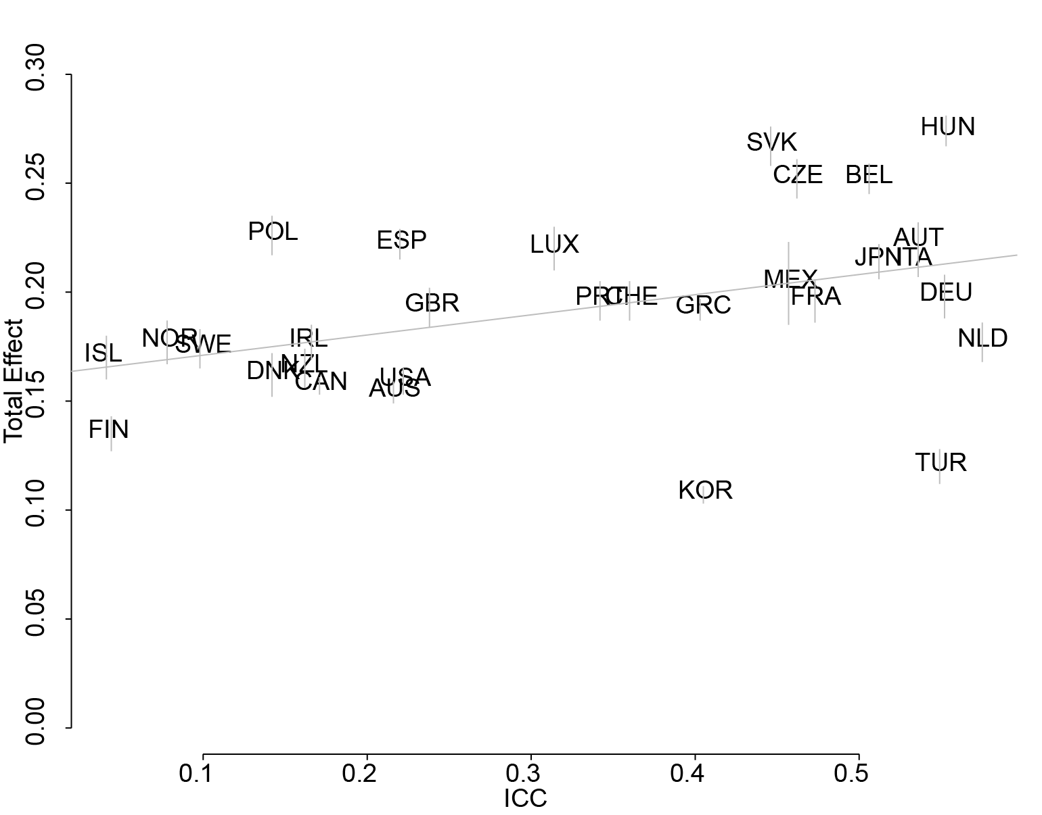a) | 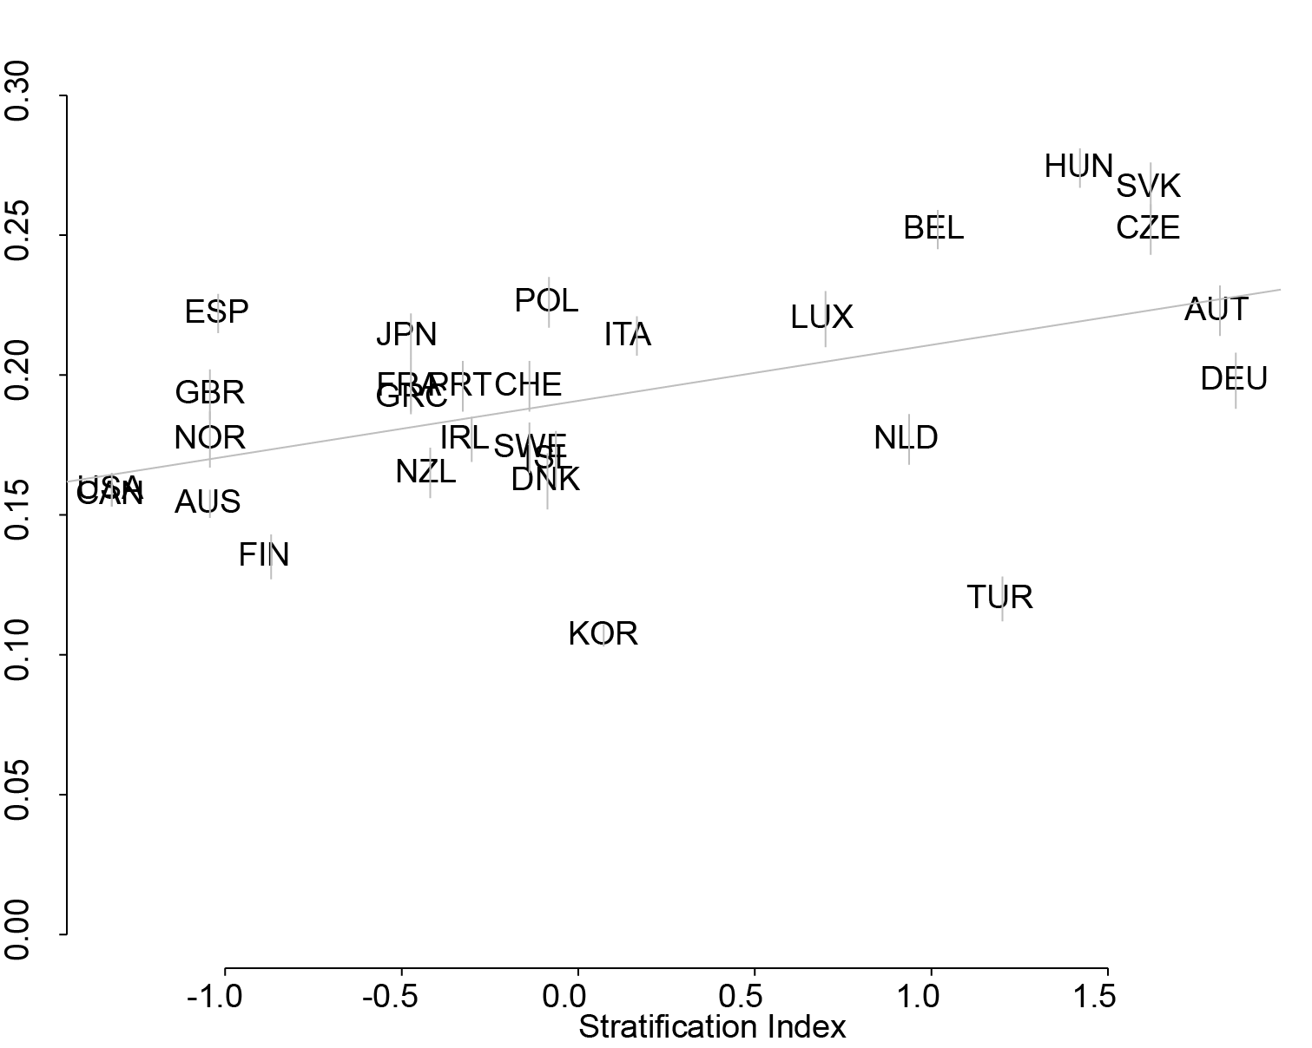b)
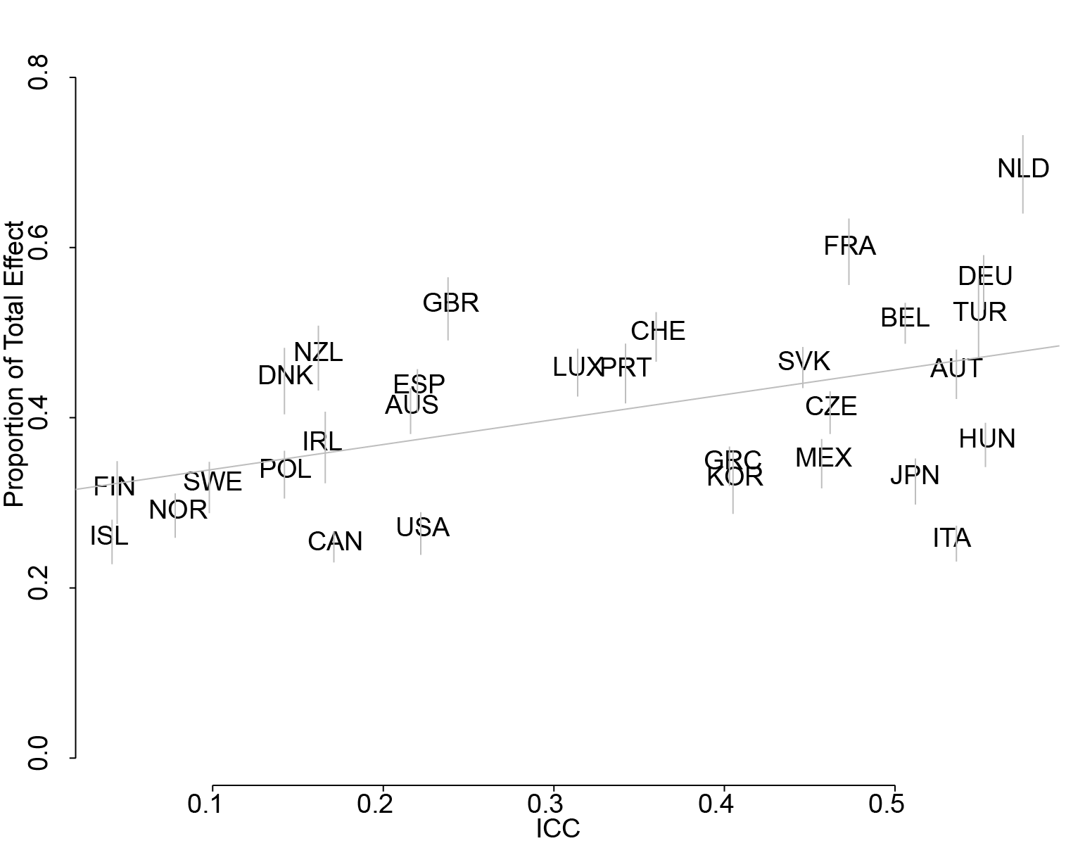c) | 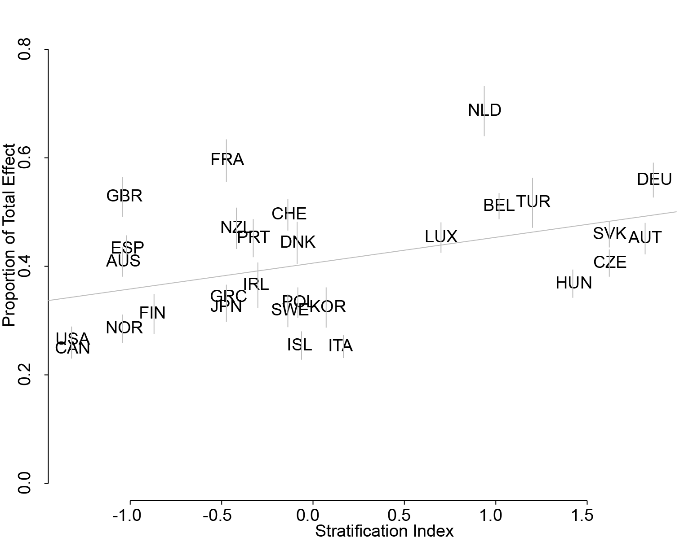d)

Figure 1. Unconditioned results for hypotheses 1 through 4.
Notes. Countries represented by their 3-letter ISO codes. Regression line provided in grey. Uncertainty around estimated total and proportion primary effects represented in by vertical grey lines. Figures in clockwise order from the top left represent: a. Results for hypothesis 1 - unconditioned, b. Results for hypothesis 2 - unconditioned, c. Results for hypothesis 3 - unconditioned, d. results for hypothesis 4 - unconditioned.

